Project Report
on

H1N1 and Seasonal Flu vaccine prediction
Carried Out at



CENTRE FOR DEVELOPMENT OF ADVANCED COMPUTING
ELECTRONIC CITY, BANGALORE.

UNDER THE SUPERVISION OF

Ancymol K. Thomas
[Scientist]
C-DAC Bangalore

Submitted By
Abhishek Jaydeo Bhure (PRN No.240850125002)
Kaname Hariom Venkatrao (PRN No.240850125042)
Shubhi Paliwal (PRN No.240850125077)
Kokate Neha Vitthal (PRN No.240850125046)
Shiva Gupta (PRN No.240850125073)

PG DIPLOMA IN ADVANCED COMPUTING/PG DIPLOMA IN IT INFRASTRUCTURE, SYSTEMS & SECURITY
C-DAC, BANGALORE

Candidate’s Declaration
We hereby certify that the work being presented in the report entitled H1N1 and Seasonal Flu vaccine prediction, in the partial fulfillment of the requirements for the award of Post Graduate Diploma and submitted in the department of Big Data Analytics of C-DAC Bangalore, is an authentic record of our work carried out during the period under the supervision of Ancymol K. Thomas, C-DAC Bangalore.

The matter presented in the report has not been submitted by me for the award of any degree of this or any other Institute/University.

Abhishek Jaydeo Bhure
Kaname Hariom Venkatrao
Shubhi Paliwal
Kokate Neha Vitthal
Shiva Gupta

Counter Signed by
Ancymol K.Thomas

ACKNOWLEDGMENT
I take this opportunity to express my gratitude to all those people who have been directly and indirectly with me during the competition of this project
I pay thank to Ancymolt K Thomas who has given guidance and a light to me during this major project. His versatile knowledge about “H1N1 and Seasonal Flu vaccine prediction” has eased me in the critical times during the span of this Final Project.
I acknowledge here out debt to those who contributed significantly to one or more steps. I take full responsibility for any remaining sins of omission and commission.

Student Name
Abhishek Jaydeo Bhure
Kaname Hariom Venkatrao
Shubhi Paliwal
Kokate Neha Vitthal
Shiva Gupta

ABSTRACT
This project focus on predicting the likelihood of an individual receiving the H1N1 and seasonal flu vaccines based on behavioral, demographic, and medical data. Using machine learning models such as Logistic Regression, SVM, Random Forest, XGBoost, and MLP, the system processes user input, applies feature engineering, and makes predictions using an ensemble learning approach. The final recommendation guides users on vaccine uptake probability. This report presents a novel vaccine prediction system designed to assess an individual’s likelihood of receiving both the H1N1 and seasonal influenza vaccines. The system integrates comprehensive user input collection, rigorous data preprocessing (including encoding, scaling, and noise reduction), and feature engineering before feeding data into an ensemble of machine learning models. For H1N1 prediction, models such as Logistic Regression, SVM, RandomForest, and a Linear model are employed, while Seasonal Flu prediction utilizes XGBoost and an MLP network. The individual predictions are combined using a weighted average ensemble approach to generate final vaccine recommendations. The weighted average will give the probability to get affected by H1N1 hence recommended to take vaccine. A detailed flowchart illustrates the sequential steps—from data collection through to final output—demonstrating the system’s architecture and its potential for supporting targeted public health strategies

.

Table Of Content:
1. Abstract
1.1 Overview of the Vaccine Prediction System
2. Introduction
2.1 Background and Motivation
2.2 Objectives of the Study
3. Software Requirement Specification
3.1 Functional Requirements
3.1.1 User Data Collection
3.1.2 Data Preprocessing
3.1.3 Feature Engineering and Selection
3.1.4 Prediction Module
3.1.5 Ensemble Processing
3.1.6 Output Generation
3.2 Non-functional Requirements
3.2.1 Performance and Scalability
3.2.2 Security and Privacy
3.2.3 Maintainability
4. Architecture
4.1 System Overview
4.2 Module Descriptions
4.2.1 User Interface Module
4.2.2 Data Preprocessing Module
4.2.3 Prediction Engine Module
4.2.4 Ensemble Module
4.2.5 Output Module
4.3 Flow Diagram
5. System Design
5.1 Input Collection
5.2 Data Preprocessing
5.3 Prediction
5.3.1 H1N1 Prediction Branch
5.3.1.1 Logistic Model
5.3.1.2 SVM Model
5.3.1.3 RandomForest Model
5.3.1.4 Linear Model
5.3.2 Seasonal Flu Prediction Branch
5.3.2.1 XGBoost Model
5.3.2.2 MLP Model
5.4 Ensemble Processing and Weighted Averaging
5.5 Output Generation
6. Implementation
6.1 Development Environment and Tools
6.2 Code Structure and Modularization
6.3 Libraries and Frameworks
6.4 Testing and Validation
6.5 Challenges and Solutions
7. Conclusion
7.1 Summary of Findings
7.2 Contributions and Impact
7.3 Future Work
8. References

INTRODUCTION
Vaccination plays a crucial role in preventing diseases like H1N1 and seasonal flu. However, individuals’ decisions to get vaccinated depend on factors such as personal concerns, medical history, behavior, and socioeconomic status.
This system uses machine learning to analyze user responses and predict vaccine adoption probability. It utilizes a weighted ensemble model that combines multiple predictions for improved accuracy.
Objectives
- Collect user input related to vaccination behavior and concerns.
- Process and normalize data using feature selection techniques.
- Provide a final recommendation based on ensemble model results.
The proposed framework begins with systematic collection of user responses regarding concerns, knowledge, behavioral practices, and demographic details. These inputs undergo meticulous preprocessing—including data formatting, encoding categorical responses, scaling numerical values, and handling missing or noisy data—to ensure robustness in subsequent analysis. Following feature engineering and selection, the system deploys separate prediction branches: one for H1N1 and one for seasonal flu. For H1N1, a combination of models including Logistic Regression, SVM, RandomForest, and a Linear model provides diverse predictive insights, while for seasonal flu, XGBoost and an MLP are utilized. Each branch’s outputs are then integrated using a weighted average ensemble, enhancing the overall prediction accuracy. The accompanying flowchart offers a visual representation of the process, from initial data acquisition to the final vaccine recommendation output, highlighting the system’s structured and scalable approach. This work aims to contribute to more informed, data-driven public health interventions by identifying individuals who may benefit from targeted vaccination campaigns.

3. Software Requirement Specification
3.1 Functional Requirements
- Data Collection:
  - The system shall prompt users to enter personal details (e.g., demographic information, vaccination perceptions, and behaviors).
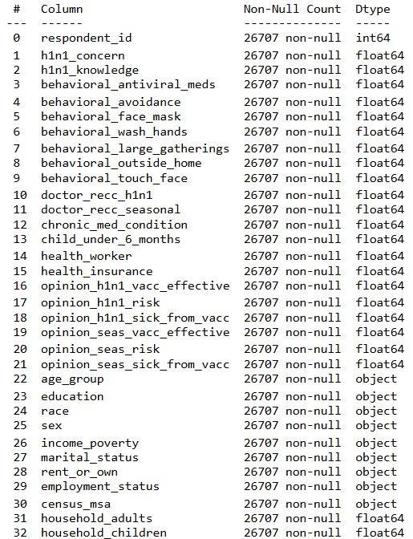
Fig.01:Data Info
- Data Preprocessing:
  - The system shall convert raw inputs into a structured format (e.g., a DataFrame).
  - It shall encode categorical data, scale numerical features, and handle missing or noisy data.
- Feature Engineering and Selection:
  - The system shall derive/select relevant features necessary for accurate predictions.
- Prediction Model:
  - The system shall implement two separate prediction branches:
    - H1N1 Branch: Utilizing models such as Logistic Regression, SVM, RandomForest, and a Linear model.
    - Seasonal Flu Branch: Utilizing models such as XGBoost and MLP.
- Ensemble Processing:
  - The system shall combine individual model predictions using a weighted average ensemble method.
- User Input:
  - Taking the user input through frontend (functions like predict_rf(), predict_svm(), predict_logistic(), etc).
  - Prediction will be performed by the trained models that shall give the output based on set questionaries asked from user.
- Output Generation:
  - Certain functions will check the difference between accuracy of each models and give output
  - The system shall display final recommendations for both H1N1 and Seasonal Flu vaccine uptake.

3.2 Non-functional Requirements
- Performance:
  - The system provides predictions as per the users input.
- Scalability:
  - It should support an increasing volume of user data without degradation in performance.
- Security and Privacy:
  - User data must be handled securely to ensure privacy.
- Maintainability:
  - The code should be modular, well-documented, and easily extendable.

4. Architecture
The system is structured as a layered, modular architecture comprising the following components:
- User Interface Model:
  - Responsible for collecting user inputs through a command-line interface or web form.
- Data Preprocessing Model:
  - Handles data formatting, encoding, scaling, and feature selection.

- Prediction Model:
  - Contains two models:
    - H1N1 Prediction model:
      - Implements multiple models (Logistic Regression, SVM, RandomForest, Linear) for H1N1 prediction.
    - Seasonal Flu Prediction model:
      - Implements models such as XGBoost and MLP for Seasonal Flu prediction.

Random Forest (Before):
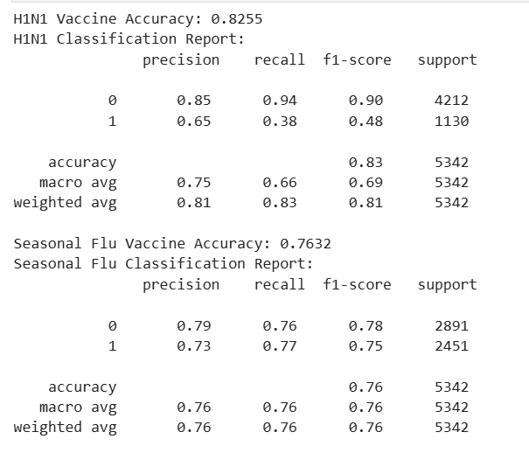
Fig.02:RF before
Random Forest (After):
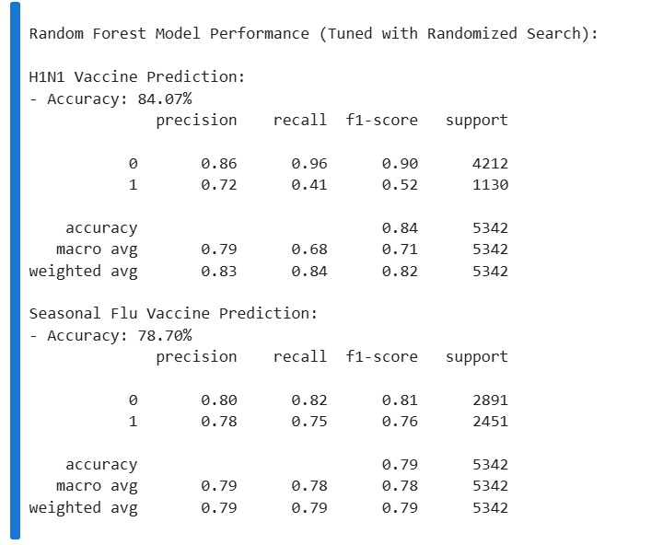
Fig.03:RF After

SVM(Before):
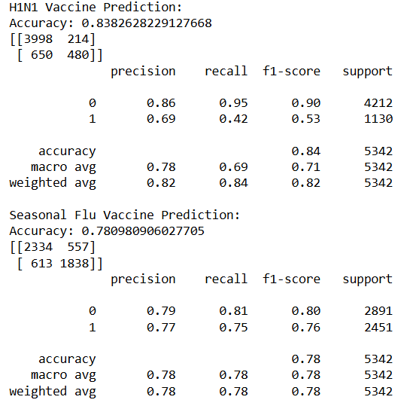
Fig.04:SVM before

SVM(After):
Fig.05:SVM After

Logistic regression (Before):
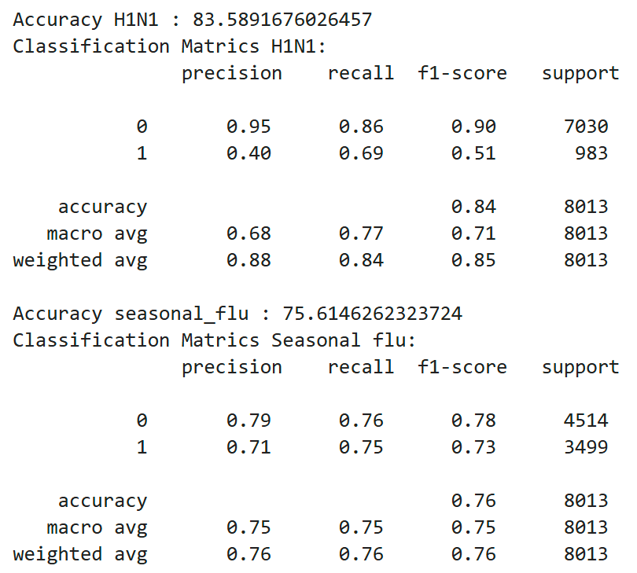
Fig.06:Logistic before
Logistic regression (After):
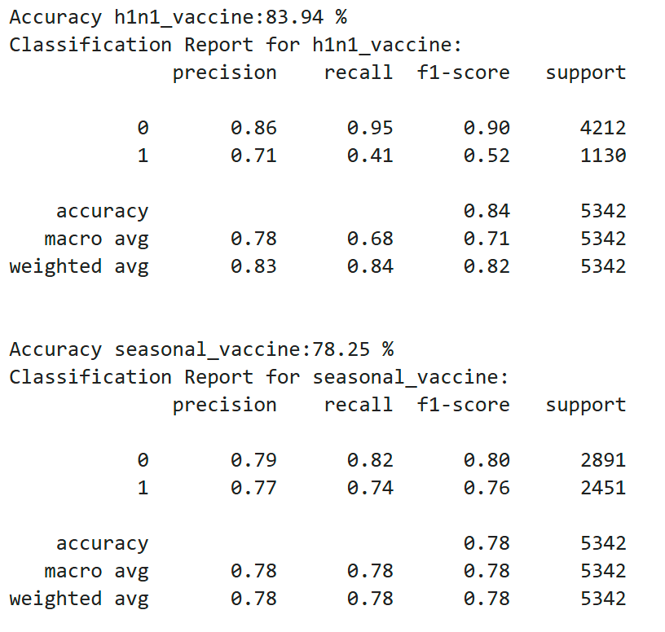
Fig.07:Logistic After

- Ensemble Module:
  - Combines outputs from individual models via weighted averaging.
- Output Module:
  - Displays the final vaccine recommendations.
A high-level flow diagram illustrates the interactions between these modules.
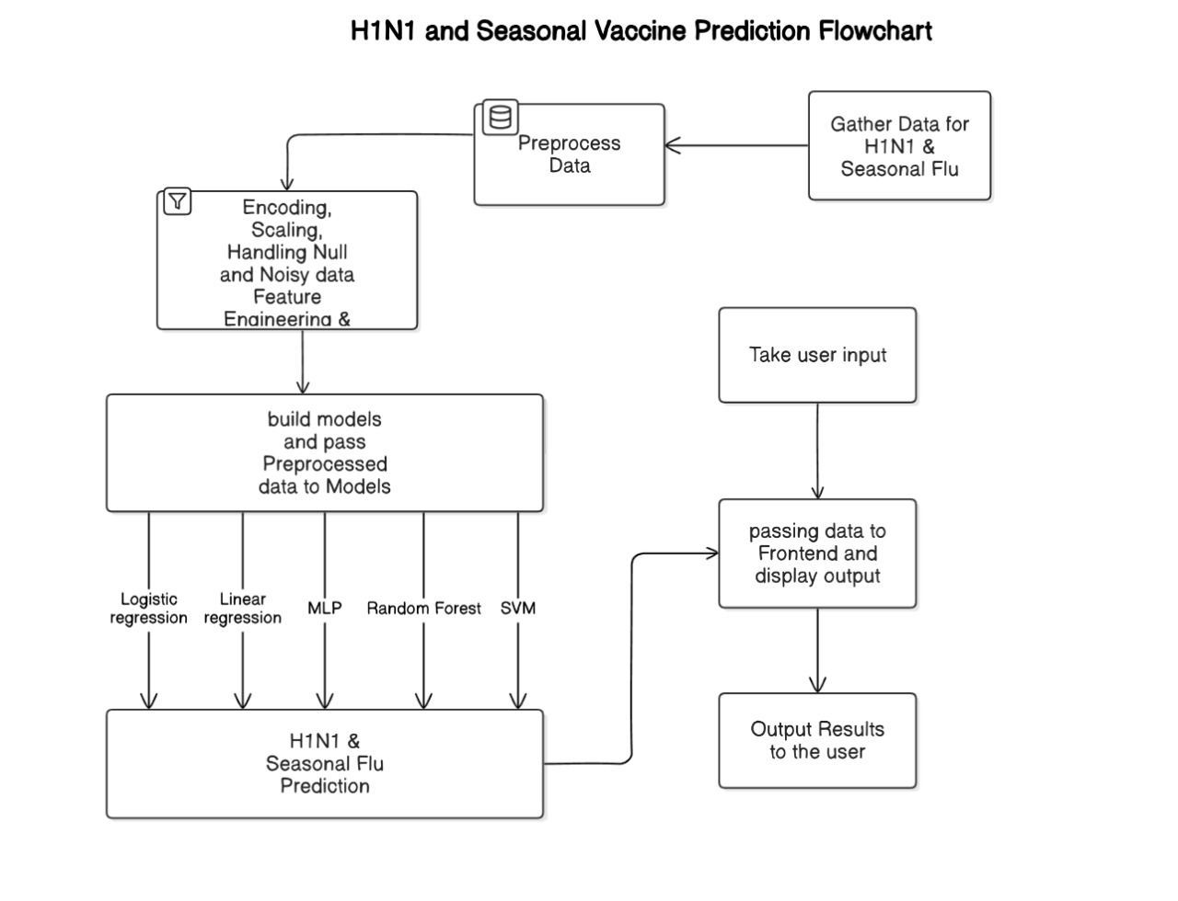Fig.08:Flow chart
5. System Design
The system design is detailed as follows:
- User Data Collection:
  - Implements functions (e.g., user_input()) that collect and store user responses in a structured dictionary.
- Data Preprocessing:
  - Converts raw inputs into a DataFrame.
  - Applies encoding for categorical variables and scaling for numerical values.
  - Performs feature engineering and selection to retain only the most relevant features.
- Prediction:
  - H1N1 Prediction Branch:
    - Processes data through Logistic Regression, SVM, RandomForest, and Linear models.
    - Uses a weighted average to combine predictions.
  - Seasonal Flu Prediction Branch:
    - Processes data through XGBoost and MLP models.
    - Combines predictions using a similar weighted average approach.
- Output:
  - Consolidates the ensemble predictions from both branches.
  - Displays final vaccine recommendations to the user.

6. Implementation
- Programming Language and Environment:
  - The system is developed in Python, making use of Jupyter Notebook or an integrated development environment (IDE) for coding and testing.
- Libraries and Tools:
  - Data Handling:
    - Pandas is used for data manipulation.
  - Preprocessing and Feature Engineering:
    - Scikit-learn is utilized for encoding, scaling, and feature selection.
    - Libraries: LabelEncoder, StandardScaler, train_test_split, accuracy_score, GridSearchCV, SVC
  - Machine Learning Models:
    - Models such as Logistic Regression, SVM, RandomForest, and Linear models are implemented using Scikit-learn.
    - XGBoost is implemented via the XGBoost library.
    - The MLP is developed using Keras and TensorFlow.
  - Ensemble Methods:
    - The ensemble predictions are computed by applying a weighted average of the outputs from individual models.
- Testing and Validation:
  - The system is tested using sample data to validate each component’s functionality and overall prediction accuracy.

7. Conclusion
This report presented a comprehensive vaccine prediction system that employs an ensemble of machine learning models to predict an individual’s likelihood of receiving the H1N1 and Seasonal Flu vaccines. By integrating robust data preprocessing, systematic feature engineering, and a dual-branch model approach, the system demonstrates an effective method for combining diverse predictive insights via weighted averaging. The modular architecture and clear system design promote scalability, maintainability, and potential integration into larger public health frameworks. Future enhancements could include real-time data integration, advanced ensemble strategies, and the incorporation of additional predictive factors to further improve accuracy and reliability.

8. References
- "Predicting H1N1 and Seasonal Flu Vaccine Cases using Ensemble Learning Approach"
Authors: Sai Sanjay S, S. Arumugam, and S. Arumugaperumal
Published in: 2020 IEEE International Conference on Computational Intelligence and Computing Research (ICCIC)Pedregosa, F., et al. (2011). Scikit-learn: Machine Learning in Python. Journal of Machine Learning Research, 12, 2825-2830.
- "Factors Mediating Seasonal and Influenza A (H1N1) Vaccine Acceptance Among Ethnically Diverse Populations"
Authors: Sandra Crouse Quinn, Supriya Kumar, Vicki S. Freimuth, et al.
Published in: American Journal of Public Health, 2011.
- "Seasonal and 2009 H1N1 Influenza Vaccine Uptake, Predictors of Vaccination, and Self-Reported Barriers to Vaccination in Middle and High School Teachers"
Authors: Allison M. Kennedy, Meghaan L. Brown, Megan L. Gustafson, et al.
Published in: Public Health Reports, 2011
- "Machine Learning Based Prediction of H1N1 and Seasonal Flu Vaccination"
Authors: S. Arumugam, S. Arumugaperumal, and S. Sai Sanjay
Published in: Advances in Electrical and Computer Technologies, Lecture Notes in Electrical Engineering, vol 698. Springer, Singapore.McKinney, W. (2010). Data Structures for Statistical Computing in Python. In Proceedings of the 9th Python in Science Conference (pp. 51-56).
- "H1N1 Flu Vaccination Prediction: A Machine Learning Project"
Authors: Emy Kessy
Published in: GitHub Repository, 2020
- White P. Study prompts provinces to rethink flu plan. Globe and Mail [Internet] 2009. Sep 27, [cited 2009 22 Dec].
- 2020 2nd International Conference on Advances in Computing, Communication Control and Networking (ICACCCN).

